ALBUQUERQUE

HORSEMEN

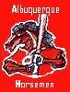

RCMBA
ERNIE HARWELL DIVISON

UNIONTOWN
RAIDERS

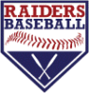

RCMBA
ERNIE HARWELL DIVISON

BURNSVILLE
BLAZE

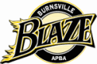

RCMBA
MEL ALLEN DIVISION

IRON CITY
HOUSEROCKERS



RCMBA
MEL ALLEN DIVISON
v

MANHATTAN
MARAUDERS

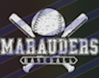
RCMBA
HARRY CARAY DIVISON

SARASOTA
BUC-O’S



RCMBA
MEL ALLEN DIVISON

LAUREL HIGHLANDS
MUSTANGS

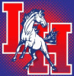

RCMBA
HARRY CARAY DIVISION

OTTAWA
FAT CATS



RCMBA
MEL ALLEN DIVISION

KENTUCKY
BLUEGRASS BOPPERS
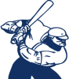
RCMBA
ERNIE HARWELL DIVISION

ROCHESTER
ROBINS

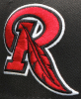

RCMBA
HARRY CARAY DIVISON

SYRACUSE
PD BLUE

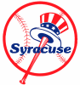
RCMBA
HARRY CARAY DIVISON

PHILADELPHIA
QUAKERS


RCMBA
HARRY CARAY DIVISION

CHESAPEAKE
EL BIRDOS

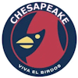

RCMBA
ERNIE HARWELL DIVISION

BENNETT RUN
BOILERMAKERS



RCMBA
MEL ALLEN DIVISION
ATLANTA
BLACK CRACKERS

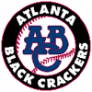

RCMBA
ERNIE HARWELL DIVISION

